[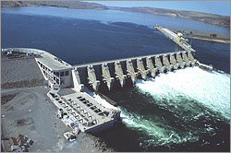](http://www.google.com/url?sa=i&rct=j&q=&esrc=s&source=images&cd=&cad=rja&uact=8&ved=0ahUKEwiMxpfM1qPZAhVO1GMKHfqYCFcQjRwIBw&url=http://www.hydroworld.com/articles/2015/03/grant-pud-begins-final-refilling-of-wanapum-dam-reservoir.html&psig=AOvVaw2TFRL_3QrphrCHPlw8jVEz&ust=1518638229958009)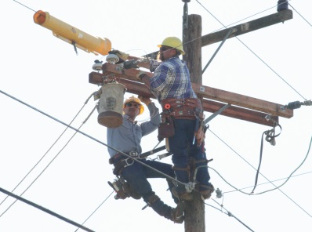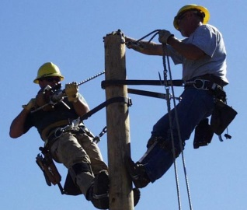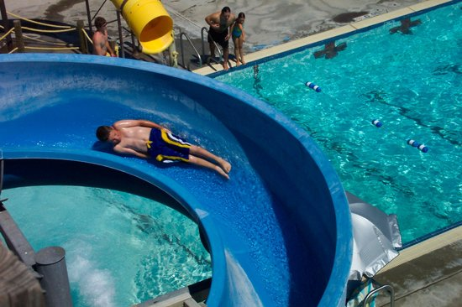

**MILTON-FREEWATER, OREGON ELECTRIC SUPERINTENDENT**

**$100,872** TO **$122,628** DOQ

PLUS EXCELLENT BENEFITS

APPLY BY **Friday, March 30, 2018**

**11:00 a.m.**

**Milton-Freewater, OR**

The City of Milton-Freewater, Oregon lies in northeast Oregon eight miles south of the City of Walla Walla, Washington, and thirty miles northeast of Pendleton, Oregon with only a twenty-minute drive to the beautiful Blue Mountains. Milton-Freewater is a community surrounded by wheat fields, vineyards and fruit orchards set against the beautiful Blue Mountains.

The City is governed by the Council/Manager form of government and enjoys a stable, supportive Council/Manager relation.

**The Community**

Long before the two towns of Milton and Freewater merged in 1951, settlers flocked to this area to take advantage of the fertile soil. Now situated within the acclaimed Walla Walla Valley wine appellation, the area is still well known for its agricultural bounty. Lots of sun in the summer and mild winters contribute to an almost perfect climate. According to the most recent census, our population is 7,070.

The City provides all City utilities, including electric service.

Two ski resorts, Bluewood and Spout Springs, are within a short driving distance. With skiing and snowmobiling in the winter and motorcycling in the summer, the mountains are great for year-round enjoyment. The area also offers bountiful opportunities for hunting, fishing, horseback riding and hiking.

Education is highly valued by the community with a unified school district including three elementary schools, a middle school and a high school. A new elementary school is under construction currently. Fine colleges and universities are within close driving distance: Walla Walla Community College, Whitman College and Walla Walla University in the Walla Walla area, Blue Mountain Community College in Milton-Freewater & Pendleton, and Eastern Oregon University in La Grande, Oregon.

**City Light and Power**

As a full-service city, the City Light and Power Department is responsible for all aspects of the City’s electric services. City power is provided through contracts with Grant County’s Wanapum Dam and the Bonneville Power Administration.

The Department has 11 FTEs and an operating budget of $9.6 million.

**The Position**

The Electric Superintendent reports directly to the City Manager, and is responsible for the day-to-day administration of the Electric department. This position directs, coordinates and is responsible for all work performed within the electric department.

**Experience & Education**

The ideal candidate will possess a Bachelor’s degree in electrical engineering or Business Administration, or a related field with a minimum of five years of progressively responsible electric utility management experience, or an equivalent combination of education and experience which demonstrates qualifications in finance, workforce development, and labor management; excellent leadership, interpersonal, and communication skills and a commitment to teamwork within a municipal environment; considerable experience in various computer software packages, including Microsoft Word, Microsoft Excel and CAD software. Candidates who can effectively demonstrate most but not all of these requirements are encouraged to apply. While public experience is desired, those individuals with private sector experience are also encouraged to apply.

**Compensation**

* $100,872 TO $122,628 DOQ
* Medical, dental, vision insurance benefits-Employee and eligible dependent premium 90% paid by City
* Long-term disability insurance
* Short-term disability insurance
* Employee Assistance Program
* Sick leave (earn 1 day/month)
* Vacation 12 days/year first four years + 10 days/year in lieu of over-time.
* 12 paid holidays
* Employer paid life insurance
* Voluntary Deferred Compensation
* Oregon State PERS Retirement

**To Apply**

The City of Milton-Freewater is an Equal Opportunity Employer. All qualified candidates are strongly encouraged to apply. To apply please send a resume, completed application and response to the supplemental questions to:

[teresa.dutcher@milton-freewater-or.gov](mailto:teresa.dutcher@milton-freewater-or.gov), fax or mail to the number or address below. Applications for consideration are required to be in the Human Resource Department by 11:00am, Friday, March 30, 2018. All information needed for this application process may be found on the City’s website at [www.mfcity.com](http://www.mfcity.com) or hard-copy application packets may be received at City Hall in the Human Resource Department. EOE

**City of Milton-Freewater**

**PO Box 6, 722 S. Main Street**

**Milton-Freewater, OR 97862**

541-938-8243 HR Direct Line

541-938-8224 FAX

[teresa.dutcher@milton-freewater-or.gov](mailto:teresa.dutcher@milton-freewater-or.gov)

[www.mfcity.com](http://www.mfcity.com)

