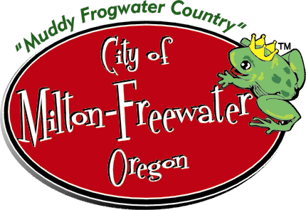 City of Milton-Freewater
AQUATIC CENTER
Employment Application

Instructions: Please complete LEGIBILY (print or type) all sections, date and sign. Incomplete application may result in elimination
for the position currently open. Request a position open notification card if you are interested in other positions.

Position applying for: _______________________________________ Date: ______________________
(Lead Lifeguard, Lifeguard, Lifeguard/Instructor-WSI certified, Concession/Cashier)

I am willing to work during the Aquatic Center season, Full-time _____ Part-time _____

Name: _____________________________________________ Phone: _____________ or ___________
Address: ___________________________________________ Email: ___________________________
___________________________________________ Email: ___________________________
City/Zip ___________________________________________
___________________________________________
(Please list both where you live in winter and summer if you are away at school.)

If working as a minor, please declare if under 18 years of age? Yes_____ No _____

When will you be available for hire? _____________________________________

EDUCATION:
High School: ________________________________ Location: _________________________________

College: ____________________________________ Location: _________________________________
Major courses of study: _________________________________________________________________

Training: Which of the following training courses have you completed and when:

(Please attach copies of certification cards)

Lifeguard Training (expires 2 yrs.) Date _____________
CPR for the Professional Rescuer (expires 2 yrs) Date _____________
First Aid (expires 2 yr.) Date _____________
Bloodborne Pathogen Training Date _____________
Water Safety Instructor (WSI) Date _____________
Food Handlers Permit Date _____________

NOTE: Applicants will not be employed until photocopies of current certifications are submitted to the
Human Resource Department in City Hall or to an Aquatic Center Pool Manager.

Any other courses, training or skills you have had relevant to this position:
_______________________________________________________Date ______ ________
_______________________________________________________Date _______________

EMPLOYMENT HISTORY: Give a brief resume' of your experience: (Jobs held and dates, duties required, etc.)
________________________________________________________________________________________________________________________________________________________________________________________________________________________________________________________________________
_______________________________________________________________________________________________________________________________________________________________________________________________________________________________________________________________________

City of Milton-Freewater is an equal opportunity employer and shall not discriminate against an employee or applicant for employment because of race, color, religion, sex, age, marital status, national origin, or mental or physical disability unless based upon a bonafide occupational qualification.

(OVER)
Are you related to any current City employee? ____ YES ____ NO

If yes, please specify name ____________________________________________

REFERENCES:

Name ___________________________________ Phone ____________________
Address ____________________________________________________________
Relationship to you ___________________________________________________

Name ___________________________________ Phone ____________________
Address ____________________________________________________________
Relationship to you ___________________________________________________

Name ___________________________________ Phone ____________________
Address ____________________________________________________________
Relationship to you ___________________________________________________

I swear that the information supplied above is accurate and true.

Signed______________________ Date________________

Social Security No.______________________ Driver’s License ____________ State______

Waiver and Authorization to Release Information

To Whom It May Concern,

I authorize you to furnish the City of Milton-Freewater with any and all information that you have concerning me, my work record, and my reputation. Information of a confidential or privileged nature may be included. Your reply will be used to assist the City of Milton-Freewater in determining my qualifications and fitness for the position I am seeking with the City.

I hereby release you, your organization and others from any liabilities or damages which may result from furnishing the information requested. I understand that any information obtained will be strictly confidential. I also understand that as a matter of policy, the City of Milton-Freewater may conduct a criminal offender check through the Oregon State Police Law Enforcement Data System ((LEDS)) and I here by give my authorization to do so. Parental authorization is needed for all applicants under age 18 along with date of birth.

____________________________________ _______________________________________________
Applicant's Signature Please Print Your Name

_________________ ______________________________________
Date Date of Birth for applications under age 18

___________________________________ ________________________________________
Parents Signature for applicant under age 18 Parent Printed Name

